

Virtualization Lab 1

ITSC 200: Network Protocols and Security

Table of Contents

Lab Outcome(s) 2

Reading 2

Introduction 2

1.0 Create a new Mint Linux VM 3

References 4

Lab Outcome(s)

* Create a new virtual machine using Virtualbox

Reading

Linux_cheatsheet_1

Introduction

This lab is to familiarize you with creating a new virtual machine in Virtualbox.

1. Create a new Mint Linux VM
   1. Start the Virtualbox application

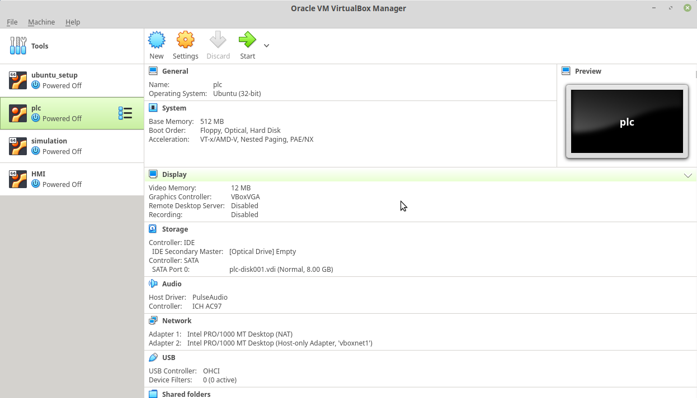

There will be no Linux Mint virtual machine (VM) to start so we need to create one.

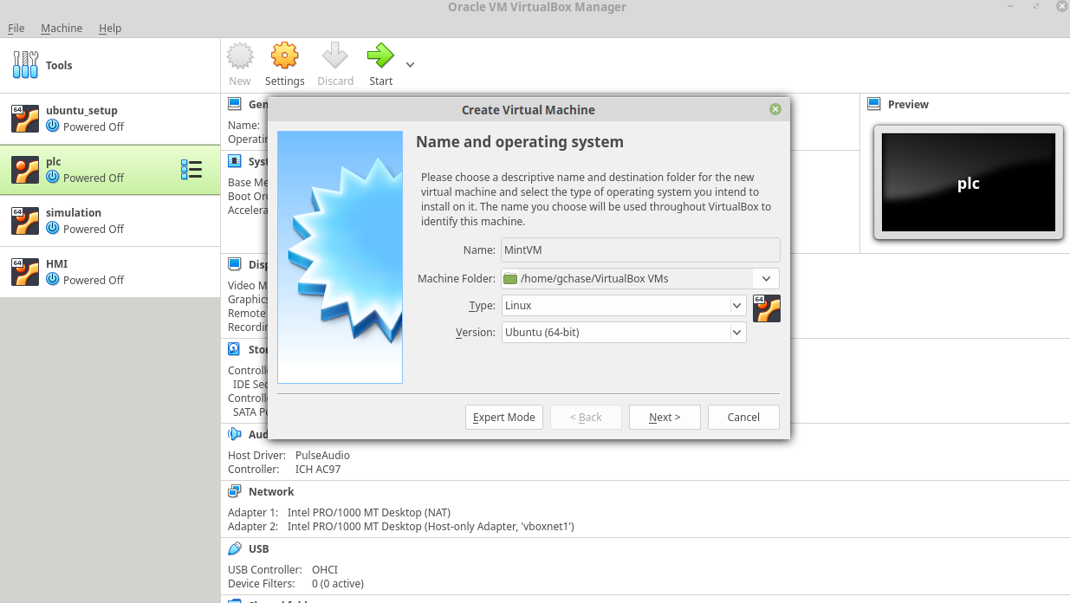

Give the VM a meaningful name and ensure that “Type” is “Linux” and the “Version” is “Ubuntu (64-bit)”. This is because Linux Mint is a distribution (distro) based on Ubuntu 64.

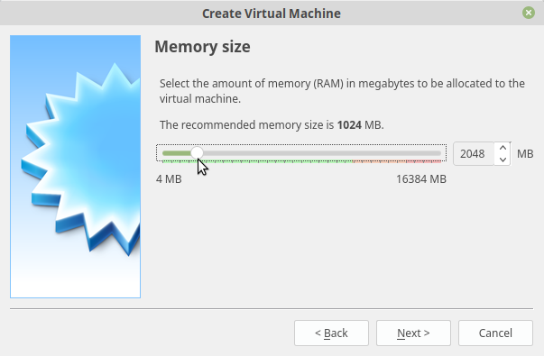

The memory size will default to 1024 MB (1 GB) but we will change it to 2048 MB (2 GB) so our virtual machine will run a bit faster.

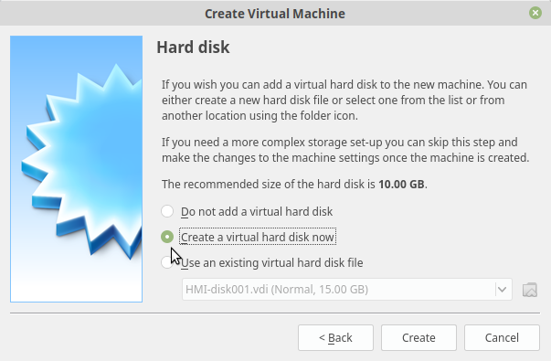

We have to create a virtual hard disk now. Our virtual machine will see this as an actual hard disk but it is actually just a file. **Anything we do to this “hard disk” will leave our real hard disk unaffected.**

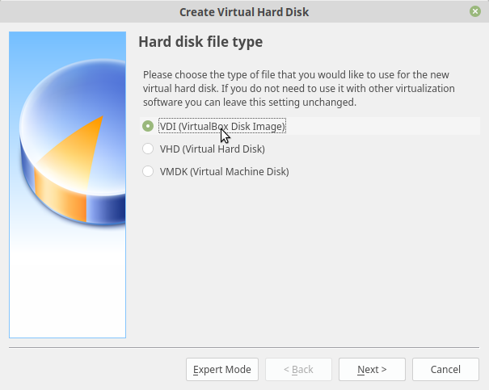

We can create virtual hard disks that are compatible with VMWare Workstation VM’s (VMDK) but we will use the Virtualbox standard of VDI.

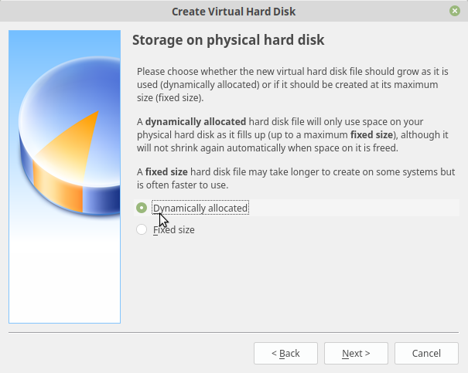

This step is important and we will ALWAYS use “Dynamically allocated”. That means that the file that represents the virtual hard disk will be physically small and will grow as needed. If we used “Fixed size” we would create a very large (mostly empty) file on our real hard drive.

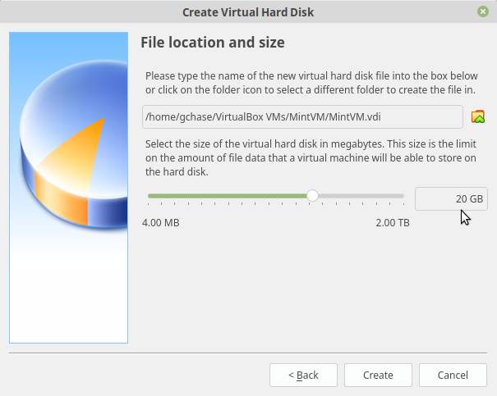

The installer will default to 10 GB but that might not be large enough so we will change it to 20 GB just in case. Use the slider or just type it in.

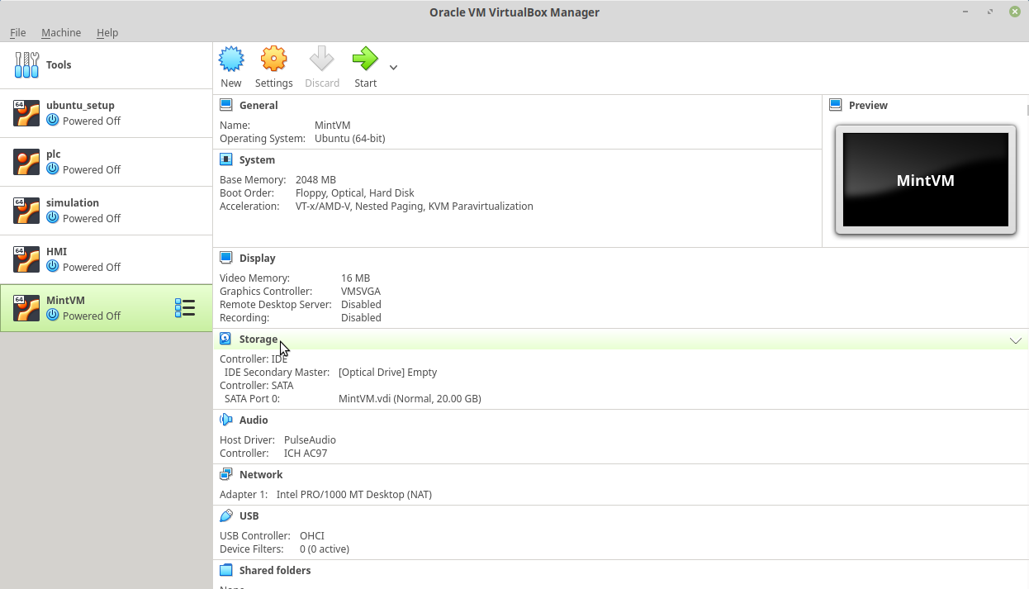

We have created a new virtual machine as seen above. Note that there is no operating system installed on this yet. It is like a new computer with a blank hard drive. We have to “put an install disk into the DVD drive (Optical drive)”. Of course we can’t physically do that because the DVD drive is virtual. What we have to do is “point” the virtual DVD drive to a .iso file which is an exact image of a DVD disk.

Before we can do that we have to download a Linux Mint ISO file. These are large files (often 2 GB or larger) so this may take some time.

Get the Linux Mint ISO file from <http://mirror.csclub.uwaterloo.ca/linuxmint/stable/20/linuxmint-20-cinnamon-64bit.iso>

If you have problems with the link, go to [https://linuxmint.com](https://linuxmint.com/) and download Linux Mint Cinnamon-64 bit manually.

Once the file has downloaded, continue with the steps below.

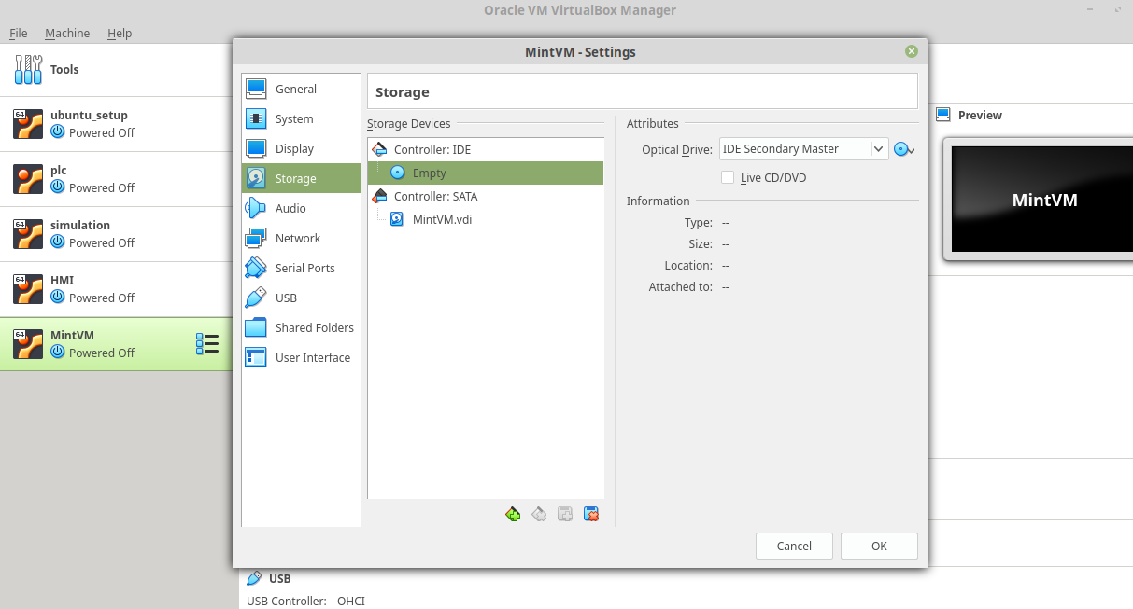

Click on “Storage” and select the CD disk icon.

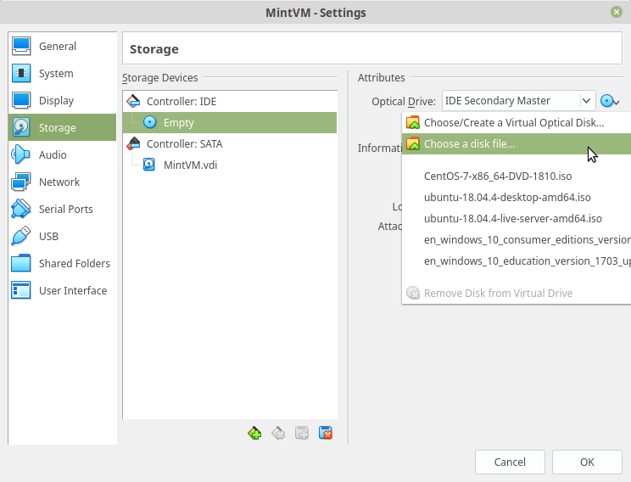

Click on the CD disk icon to the right of the window and use the “Choose as disk file” to navigate to your downloaded linux mint .iso file.

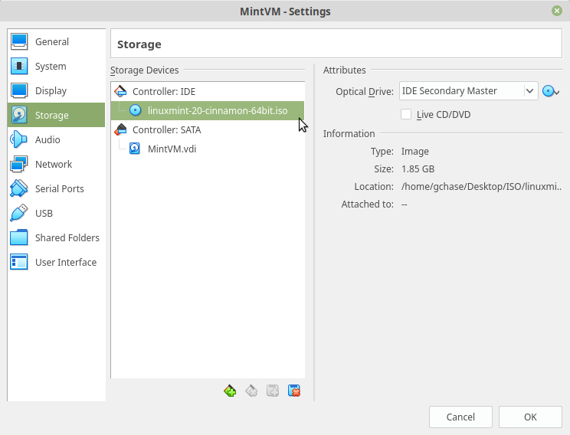

Notice that your VM is now connected to the Linux Mint ISO file.

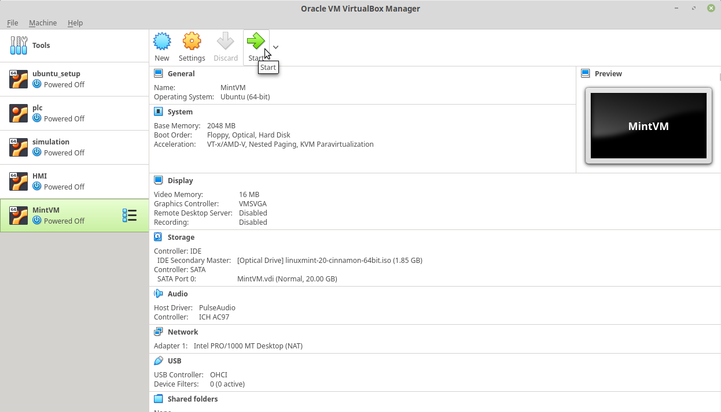

At this point, you are ready to start your VM and start installing Linux Mint onto your new virtual machine. Note that Linux Mint is what is called a “Live Distribution” meaning that when you start your virtual machine Linux Mint will start running directly off of the “CD”. In other words, you will actually have a running Linux Mint VM before you even go through the install steps.

If you shut down your virtual machine at this point any changes you have made will be lost. To create a VM that saves changes, we have to actually install the Mint operating system onto your new virtual machine.

**2.0 Installing Mint onto your Virtual Machine**

Follow the instructor’s steps to actually install the Mint operating system onto your virtual machine as I demonstrated in class. If you missed the class or if you want to review the steps, please view the recorded class session.

3.0 Use basic Linux commands

1. After starting your new VM, you will see something similar to the screen shot below. Follow the directions to open a command window (sometimes called a terminal window).

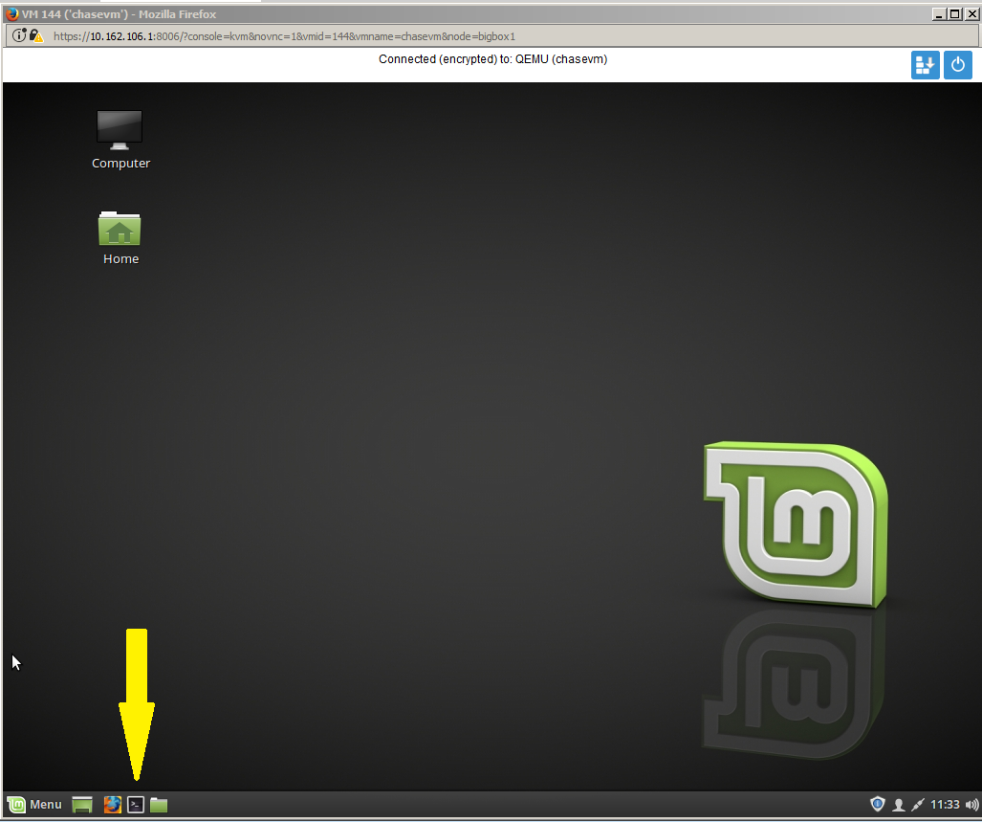

1. You will see a window, as below.  
     
   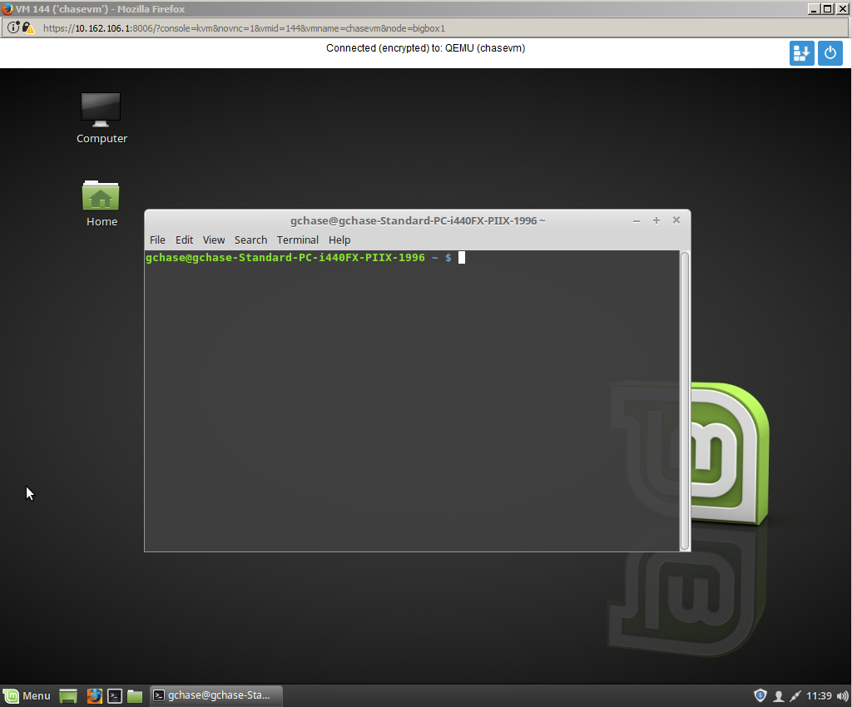
2. Using your cheatsheet, find the IP address of your VM.  
     
   IP Address ___________________________________
3. Type in the following command to install Kazam (a screen capture and video capture program) so you can take screen shots of your work.  
   1. *sudo apt-get update* (let this run as it will take a while)
   2. *sudo apt-get install kazam*
4. You will be asked to confirm the install (y). The Kazam application will be downloaded from the Internet and installed on your VM.
5. Take a screen capture of your VM with your terminal window open and the results that were displayed when you typed in the commands to answer the following questions :  
   1. What is the IP address of your VM ?
   2. Where are you in the file system (ie: your current location) ?
   3. What is the username that you are currently logged in as ?
6. Type “sudo shutdown -h now” to properly power down your virtual machine.
7. Upload your screen capture to the assignment called **OS_lab1** in Brightspace (learn.sait.ca)
8. You now have a Linux VM that you can use to practice Linux commands. Feel free to install another VM or two to use in other courses or to practice with. They do not consume RAM when they are not running.

References

Linux _cheatsheet_1

Blank page if necessary to make pages an even number

**DO NOT DELETE THE SECTION BREAK BELOW. DELETING IT MAY IMPACT THE FORMATTING IN THIS DOCUMENT.**